Section I: Scenario Demographics

Scenario Title: | Newborn Sepsis with Apneas
Date of Development: | 29/AUG/2016
Target Learning Group: | Juniors (PGY 1 – 2) Seniors (PGY ≥ 3) All Groups

Section II: Scenario Developers

Scenario Developer(s): | Rob Woods
Affiliations/Institution(s): | University of Saskatchewan & Waitemata DHB, NZ
Contact E-mail (optional): | Rob.woods@usask.ca

Section III: Curriculum Integration

Learning Goals & Objectives
Educational Goal: | To review the management of the septic newborn
CRM Objectives: | - Effectively lead a newborn resuscitation and seek input from others  - Use effective communication strategies, including closed loop communication and summarizing events for team
Medical Objectives: | - Recognize sepsis and shock in the newborn  - Rapidly estimate pediatric weight for medication dosing  - Obtain efficient vascular access and initiate fluid resuscitation  - Initiate early broad-spectrum antibiotics.  - Recognize recurrent apneas as an indication for intubation and plan for a safe intubation accordingly

Case Summary: Brief Summary of Case Progression and Major Events
A 3-day-old term male infant is brought to the ED by EMS after being seen at their Family Physician’s office with a low temperature (33.1ºC). The child has been feeding poorly for about 12 hours, and has vomited twice. He is lethargic on examination and poorly perfused with intermittent apneas lasting ~ 20 seconds. He requires immediate fluid resuscitation and broad-spectrum antibiotics. His perfusion will improve after IVF boluses, however the apneas will persist and necessitate intubation.

References
http://emedicine.medscape.com/article/972559-overview, PALS & APLS courses

Section IV: Scenario Script

A. Scenario Cast & Realism
Patient: | Computerized Mannequin |  |  |  |  | Realism:  Select most important dimension(s) |  |  | Conceptual
 | Neonatal Mannequin |  |  |  |  |  |  |  | Physical
 | Standardized Patient |  |  |  |  |  |  |  | Emotional/Experiential
 | Hybrid |  |  |  |  |  |  |  | Other:
 | Task Trainer |  |  |  |  |  |  |  | N/A
Confederates | Brief Description of Role
Resus Nurse | Hooks patient up to monitors, provides additional vitals if requested (Blood sugar 2.7, Temperature 33.1ºC). Frequently describes the patient as looking pale/mottled, rapid HR, prolonged capillary refill.
B. Required Monitors
EKG Leads/Wires |  |  | Temperature Probe |  |  |  | Central Venous Line
NIBP Cuff |  |  | Defibrillator Pads |  |  |  | Capnography
Pulse Oximeter |  |  | Arterial Line |  |  |  | Other:
C. Required Equipment
Gloves |  |  | Nasal Prongs |  |  |  | Scalpel
Stethoscope |  |  | Venturi Mask |  |  |  | Tube Thoracostomy Kit
Defibrillator |  |  | Non-Rebreather Mask |  |  |  | Cricothyroidotomy Kit
IV Bags/Lines |  |  | Bag Valve Mask |  |  |  | Thoracotomy Kit
IV Push Medications |  |  | Laryngoscope |  |  |  | Central Line Kit
PO Tabs |  |  | Video Assisted Laryngoscope |  |  |  | Arterial Line Kit
Blood Products |  |  | ET Tubes |  |  |  | Other: Broselow tape
Intraosseous Set-up |  |  | LMA |  |  |  | Other: Neonatal warmer
D. Moulage
Infant mannequin to be described or dressed as a 3-day old male infant, weighing 4kg at birth.

E. Approximate Timing
Set-Up: |  | 10 min |  | Scenario: | 15-20 min |  |  | Debriefing: |  | 20-30 min

Section V: Patient Data and Baseline State

A. Clinical Vignette: To Read Aloud at Beginning of Case
To be stated by the Paramedic with the Resus Nurse at bedside: “We picked up this term 3-day old male infant at their GPs office. Mom reports poor feeding for the past 12 hours, and two episodes of vomiting. They took him to the GPs office this morning and they found the temperature to be quite low at 33.1°C. They called us concerned about sepsis. We were only 5 minutes away so we have not obtained IV access. We did obtain a glucose level of 2.7. The child is lethargic and has very poor perfusion – peripheral cap refill is 7 seconds. We don’t have a cuff to get an accurate BP but the HR is 190.”
B. Patient Profile and History
Patient Name: Jake Brown |  |  |  |  | Age: 3 days |  |  |  |  |  | Weight: Birth weight 4kg  Grey on Broselow tape
Gender: M F |  |  |  |  | Code Status: Full
Chief Complaint: Low temperature at GP.
History of Presenting Illness: Poor feeding x12 hours, vomiting.
Past Medical History: |  | Term infant.  Normal pregnancy.  GBS+  Premature ROM.  Got Abx before delivery. |  |  |  |  | Medications: |  |  |  |  | None
Allergies: None
Social History: Lives with Mom and Dad
Family History: None
Review of Systems: |  | CNS: |  | Nil.
 |  | HEENT: |  | Nil.
 |  | CVS: |  | Nil.
 |  | RESP: |  | Nil.
 |  | GI: |  | Poor feeds x12 hours. Vomited twice in 24 hours.
 |  | GU: |  | Only 2 wet diapers today.
 |  | MSK: |  | Nil. |  |  |  | INT: |  |  |  |  |  |  | Nil
C. Baseline Simulator State and Physical Exam
No Monitor Display |  |  | Monitor On, no data displayed |  |  |  |  |  |  | Monitor on Standard Display
HR: 190/min |  | BP: 50/palp |  |  |  | RR: 40/min with apneas |  |  |  |  |  |  | O₂SAT: 93%, drops to low 80s after apneas
Rhythm: NSR |  | T: 33.1ºC |  |  |  | Glucose: 2.7 mmol/L |  |  |  |  |  |  | AVPU: Pain only
General Status: Eyes closed, cries weakly with external stimulation
CNS: | PERLA, 3mm bilaterally.
HEENT: | Normal
CVS: | Cap refill 7 seconds peripherally, 5 seconds centrally, mottled extremities
RESP: | Shallow resps with 20-30 second apneas every 5 mins
ABDO: | Soft, not distended. No rebound or guarding.
GU: | Nil.
MSK: | Nil. |  |  |  |  |  |  |  | SKIN: |  |  |  |  | Mottled extremities

Section VI: Case Progression
Scenario States, Modifiers and Triggers
Patient State | Patient Status | Learner Actions, Modifiers & Triggers to Move to Next State
1. Baseline State  Rhythm: Sinus  HR: 190/min  BP: 50/palp  RR: 40/min, shallow  O₂SAT: 93% RA  T: 33.1ºC rectal | GCS – AVPU | Learner Actions  - Primary survey and coordination of team  - Monitors  - Establish iv or IO access  - Determine weight of child (birth weight, Broselow tape, age based)  - Push dose fluid boluses (20ml/kg x3)  - Re-check glucose (1.8mmol/L)  - Correct hypoglycemia (5cc/kg of D10W)  - Broad-spectrum ABX (cefotaxime 100mg/kg + ampicillin 100mg/kg) | Modifiers  - 1st fluid bolus CRT 5 sec peripheral, 3 sec central, HR 175, BP 60/30  Triggers  - 2nd bolus 2. Apneas  - No glucose given by 5 min 3. Seizure
2. Apneas  HR: 175/min  BP: 65/35  RR: Apnea x20 sec then back to 40  O₂SAT: drops to 81% with apnea then back to 93% | GCS - AVPU | Learner Actions  - Recognize apnea with desaturation, provide supplemental oxygen  - Administer 3rd fluid bolus  - Establish IV access  - Draw labs including VBG, lactate, cultures  - Re-check glucose (9.7mmol/L)  - Portable CXR  - Call for high flow O2  - Prepare for definitive airway management (including push-dose pressor at bedside) | Modifiers  - No recognition of apnea, no O2 applied, or no preparation to intubate Repeat apneic episode  Triggers  - 3rd bolus given and O2 applied OR 5 min into state 4. Persistent Apnea
3. Seizure  HR: 180  BP: 85/45  O₂SAT: 88% | Patient actively seizing | Learner Actions  - Re-check glucose (1.8mmol/L)  - Correct hypoglycemia (5cc/kg of D10W) | Modifiers  - No glucose check RN cues  Triggers  - Glucose replaced  2. Apneas
4. Persistent Apnea  HR: 160  BP: 70/45  RR: apnea  O₂SAT: drops to 81% then slowly to 75% | GCS - AVPU | Learner Actions  - Assist ventilation with BVM until ready to intubate  - Administer appropriate induction agent ± paralytic + atropine  - Intubate using appropriate tube size (3 cuffed or 3.5 uncuffed) and depth (9cm) | Modifiers  - BVM prior to intubation O₂SAT 99%  Triggers  - No BVM or intubation delayed >3 min 5. PEA  - Successful intubation  6. Resolution
5. PEA  Rhythm: sinus  HR: 45/min  BP: 0  RR: 0 | Pulseless | - Initiates CPR with appropriate 15:2 ratio  - ± Crash intubation  - Epi iv at 0.01mg/kg | Triggers  - Successful intubation  6. Resolution  - 3 rounds CPR no intubation 4. Persistent Apnea
6. Resolution  HR: 150  BP: 70/45  O₂SAT: 98%  RR: 40 | GCS - AVPU | Learner Actions  - Consult Peds ICU  - Post-intubation CXR  - Cath urine for urine culture | End Case PRN

Section VII: Supporting Documents, Laboratory Results, & Multimedia

Laboratory Results
No blood work is provided during the case.

Images (ECGs, CXRs, etc.)
Initial CXR
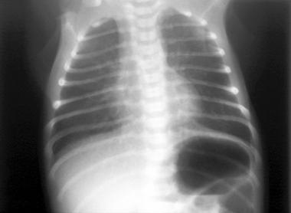
(CXR source: http://emedicine.medscape.com/article/414608-overview)
Post-Intubation CXR
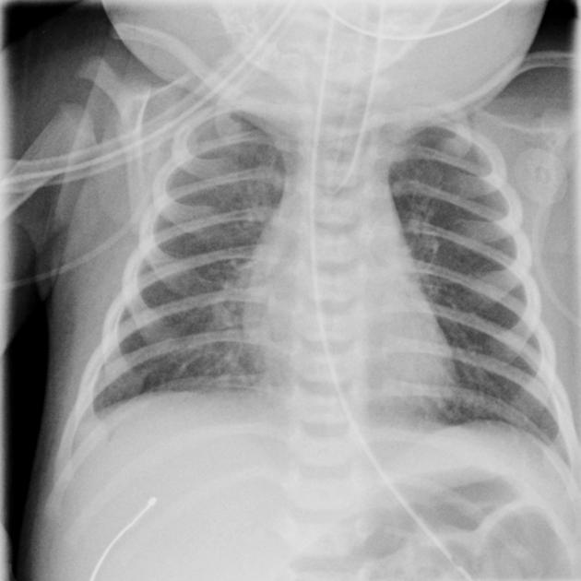
(CXR source: https://radiopaedia.org/articles/neonatal-pneumonia)
Ultrasound Video Files (if applicable)
None required.

Section VIII: Debriefing Guide

General Debriefing Plan
Individual | Group |  | With Video | Without Video
Objectives
Educational Goal: |  | To review the management of the septic newborn
CRM Objectives: |  | - Effectively lead a newborn resuscitation and seek input from others  - Use effective communication strategies, including closed loop communication and summarizing events for team
Medical Objectives: |  | - Recognize sepsis and shock in the newborn  - Rapidly estimate pediatric weight for medication dosing  - Obtain efficient vascular access and initiate fluid resuscitation  - Initiate early broad-spectrum antibiotics.  - Recognize recurrent apneas as an indication for intubation and plan for a safe intubation accordingly
Sample Questions for Debriefing
- Did you feel that your team leader had control over the room? Did he or she ask for input?
- Do you feel you communicated well as a team?
- What were your priorities in managing this patient? How did they change as the case progressed?
- What was the cause of this patient’s abnormal vitals signs and level of consciousness? Why was the patient having apneas?
- How do you get vascular access in a newborn?
- What infectious agents are you trying to treat with your antibiotic choices? Which is the more important antibiotic to give?
- How do you manage hypothermia in the context of sepsis? What tactics did you use in this patient?
Key Moments
Recognition of toxic neonate and need to initiate immediate fluid boluses.
Recognition of apneas and initial management steps (fluid boluses, O2, high-flow O2)
Recognition of need to intubate

